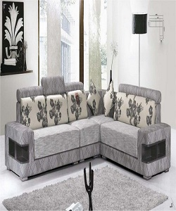

Lounge Sofa

$163.34

Availability: In stock

Description

Classic look Polyester perfectly fits in any style of Lounge, backyard and garden decor, you can Place it anywhere in room and TV room also, and it has a soft and comfortable.